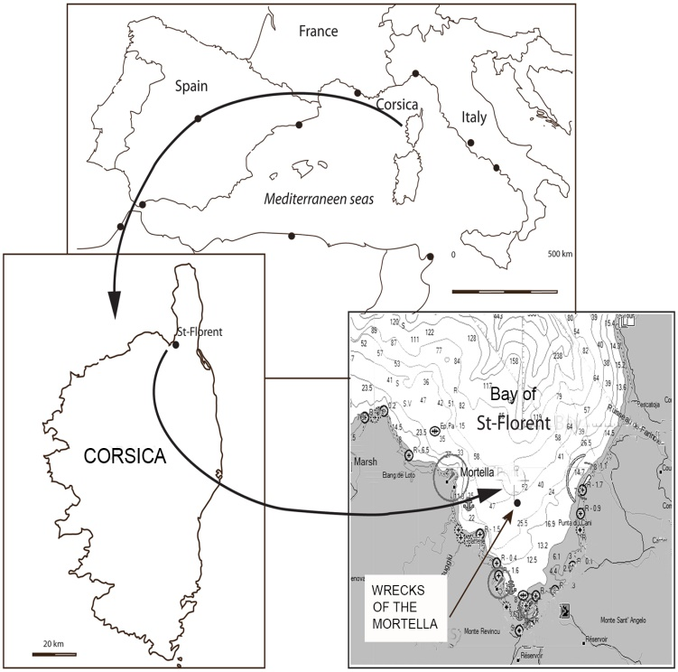
MORTELLA III
Country: France
Place: Bay of Saint-Florent (Upper-Corsica), France
Coordinates (approximate): 42º42.200E – 09º17.200N
Type: Genoese nave
Identified: Boscaina or Ferrara
Dated: August 1527

Introduction
The Mortella shipwrecks were discovered during a side scan SONAR survey program led by the Centre d’Études en Archéologie Nautique (Nautical Center for Nautical Archaeolgy) –CEAN- in the North of the island of Corsica (Bay of Saint-Florent, Upper-Corsica). These 16th century wrecks were named Mortella II and III in reference to the Genoese tower of the same name in front of which they lie. The site of Mortella I is a mooring place located at the foot of the tower where ceramic shards attest to its activity over the past centuries.
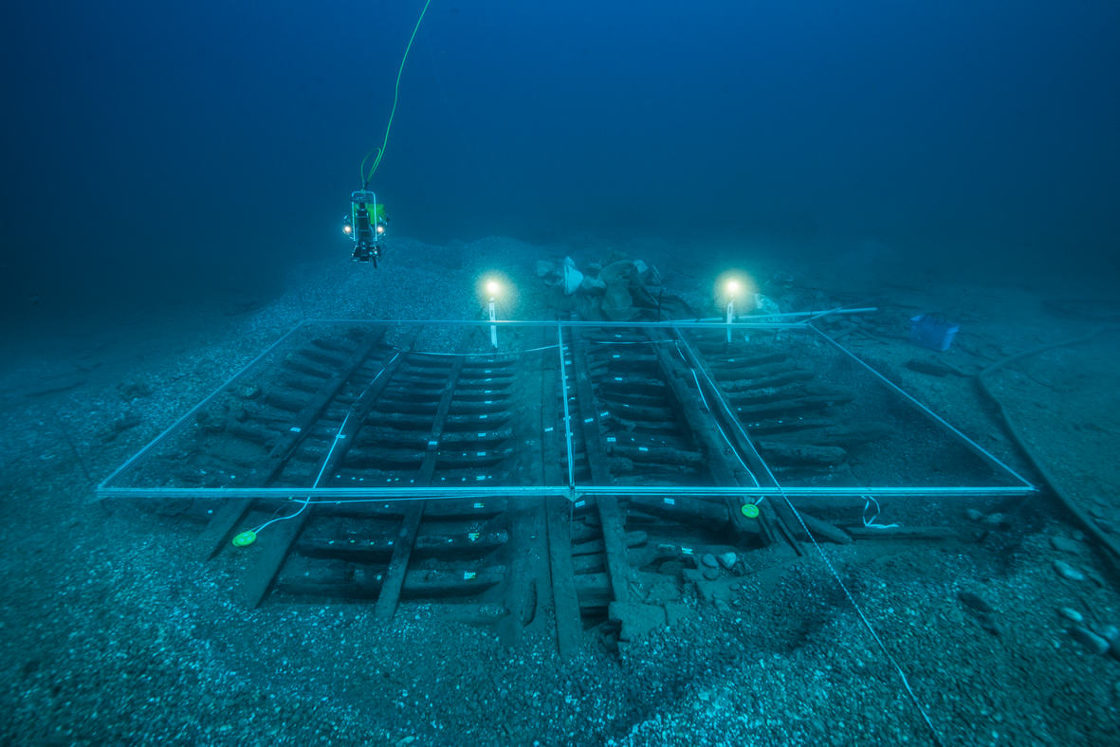
Excavation of the Mortella III wreck at mid-ship. Photo C. Gerigk.
Mortella II was located in October 2005 at a depth of 48 meters. About 700 meters to the South, the second site, - Mortella III – uncovered in November 2006, in 37 meters of water. They were characterized by the remains of two wooden hulls covered with ballast gravel and stones, several large anchors and pieces of wrought iron artillery along with other artifacts scattered on the bottom.

The archaeological excavations carried out on the Mortella III wreck between 2010 and 2019 highlights the Mediterranean technical culture from the early modern period. The dendrochronology study together with the archival research made it possible to identify the wrecks as the Boscaina and the Ferrara, two seagoing Genoese navi sunk in the Bay of Saint-Florent in August 1527.

WEB sites:

Mortella’s blog: https://peciomortella.wordpress.com/

CEAN’s blog : http://www.archeologiesousmarine.org/

Project and Team
The project has been mainly focused on the study of the well-preserved remains of the hull. It has been carried out by CEAN and supported by the French Ministry of Culture (DRASSM), by the Government of Corsica (CdC), the EU (Marie Slodowska Curie Actions, Horizon 2020, GA No. 843337) and the Spanish National Research Council, CSIC.
An international team of archaeologists and professionals has been gathered with the collaboration of the University of Paris-Sorbonne (FED 4124), the University of Corsica Pasquale Paoli, the J. Richard Steffy Ship Reconstruction Laboratory, Texas A&M University, the Spanish National Research Council–CSIC-, the ForSEAdiscovery consortium, the University of Wales, the Archaeological Service of Neuchâtel (OPAN) Switzerland, the Groupe de Recherches en Archéologie Navale (GRAN), the University of Avignon (IBM UMR 7263), the University of Genoa (NavLab), AINGURAK (Spain), the Maritime Archaeology Trust (MAT, UK), ACORROS conservation laboratory.

Six excavation campaigns have been carried out on the site. Its results have been published in 2020:
Cazenave de la Roche, Arnaud, 2020, The Mortella III wreck: a spotlight on Mediterranean Shipbuilding of the 16th century. British Archaeology Report – BAR Publishing, Oxford, 2020.

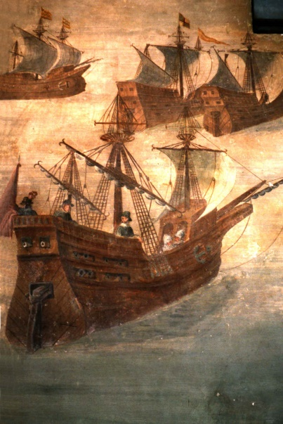
Story of the Ship
The Literature research carried out in parallel with the excavation in Italian, French and Spanish archives and libraries helped to draw a historical portrait of these Genoese navi. The Mortella wreck are most likely the Boscaina and the Ferrara, commercial ships originating from Rapallo - a port located 25 km southeast of Genoa and allied to it.
The discovery of the primary sources accounts of Agostino Giustiniani and Paolo Giovio, author’s contemporary with the events, allow detailing them. They provide a double level of information:
1 - First of all, on the shipwrecks themselves, depicting how the two navi were trapped in the Bay of Saint-Florent in mid-August 1527. For lack of wind they were no longer able to sail and condemned to be caught by a fleet of French galleys approaching the bay with all oars. With no way to escape, the crews landed and scuttled the two ships by setting them on fire to prevent them from falling into enemy hands.
Genoes nave of the XVIth c. (Fresco of the Alvaro de Bazan castle, Spain)

2 - The second level of historical information concerns the general political context leading to the shipwreck: in this case the wars of Italy in 1527, with the blockade of Genoa undertaken by a group of allied fleets known as the "League of Cognac", including the French fleet, that of Pope Clement VII, Venice, Florence and Andréa Doria, who at the time was still François Ist's armed wing in the Mediterranean. Doria did not hesitate to strike Genoa, his own home town, itself allied with Charles V's Spain. Therefore the wrecks of Mortella are referred to this complex and tumultuous context of the Seventh Italian War. Indeed, we know today that the two Genoese ships, the Boscaina and the Ferrara, were on a mission to try to supply Genoa starving by the blockade with Sicilian grain

Loss
Mid-August 1527

Find
November 2006

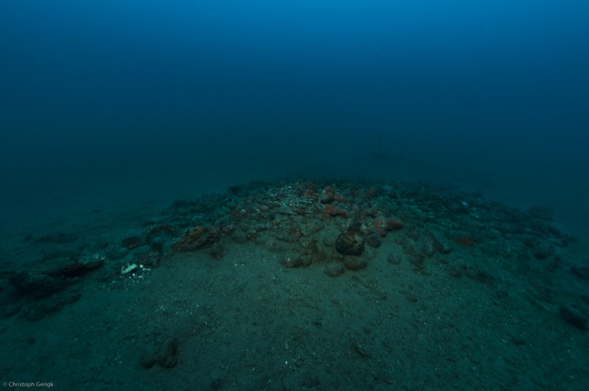
Tumuli and ballast

The Mortella III site has a curious layout with two distinct archaeological sets represented by two tumuli meeting in its north-east part. These two tumuli of 20 and 35 meters in extension are made of a big amount of ballast stones and gravel. This dual layout can probably be explained by the fact that once the fire had reached the waterline, the hull would have been dragged down by more than 100 t. of ballast and would have torn longitudinally by striking the bottom violently from the stern.
The tumulus B of the Mortella III wreck. Photp C. Gerigk

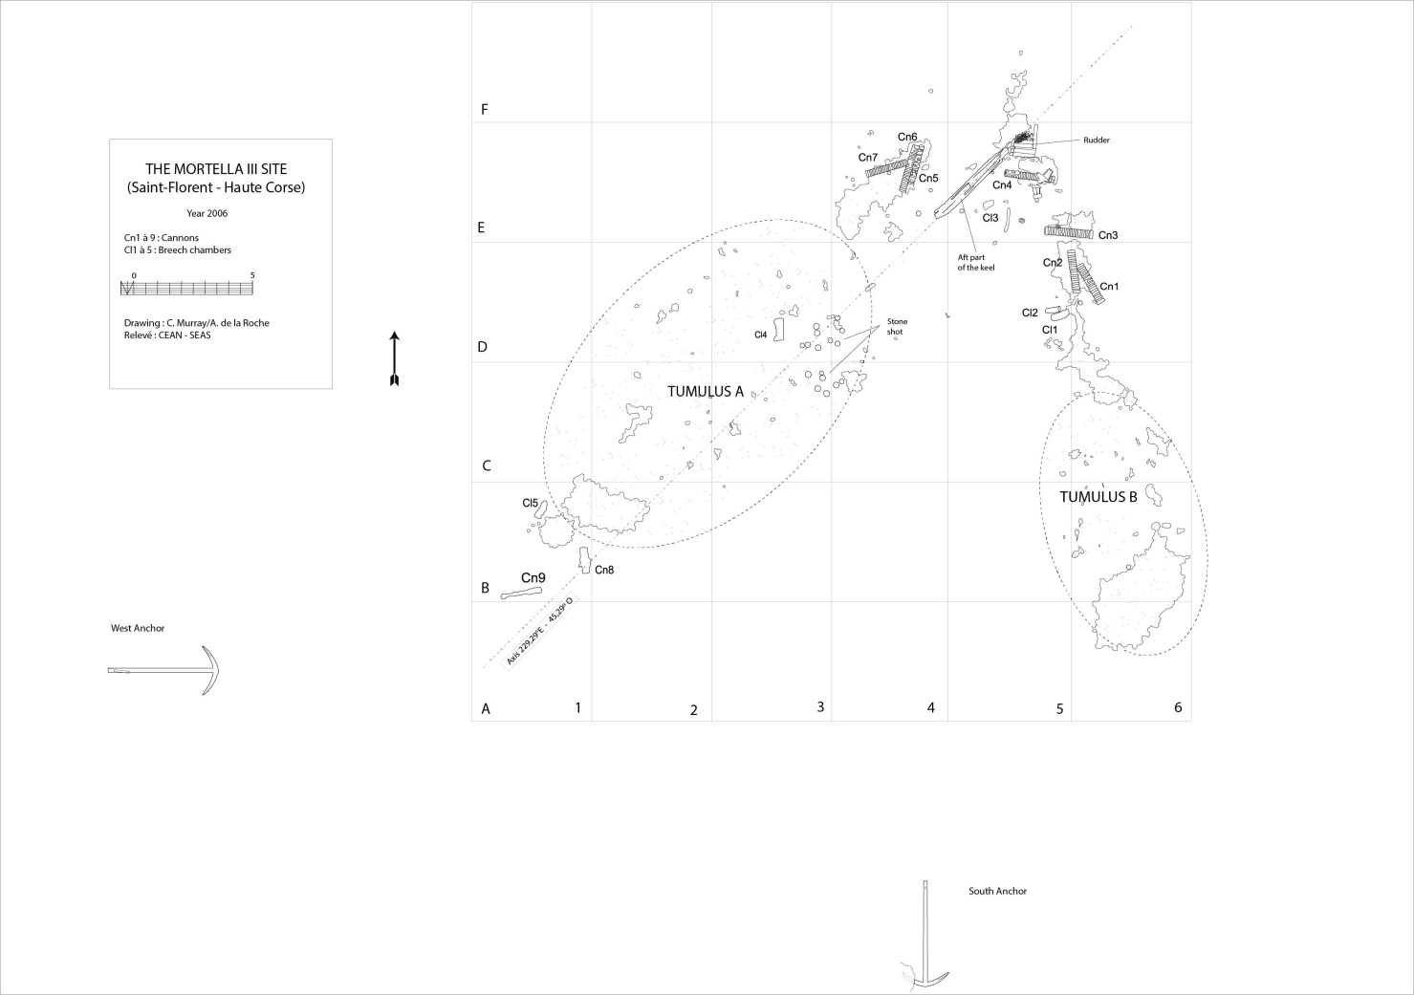
General planimetry of the site before its excavation – Tumulus A (left). Tumulus B (right)

The link between Mortella II and III wrecks
The geographical proximity of the Mortella II and III wrecks combined with the similarity of their artefacts, in particular their artillery and anchors, led to the conclusion that they were likely involved in the same historical event.
The petrographic analysis confirmed the link between the two sites by highlighting the same geological nature of the ballast stones. The conclusion of this study states:
‘These observations suggest that the stones from Mortella II are similar to those from the tumuli A and B of Mortella III. We concluded they were made of sandstone limestone more or less rich, depending on the sample, in sandstone or limestone while the white veins were calcite... It therefore appears that the Mortella II and III wrecks were certainly weighted with the same ballast stones, which could mean a common origin.’

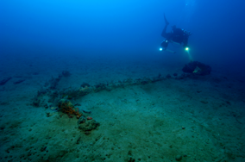
Anchors
Two iron anchors lie on the periphery of the site:

The West anchor. It is located about 15 metres west of the southern edge of tumulus A. It is oriented on an east/west axis. It has a length of 4.5 metres. At its western end, an attachment ring is turned back along the shank of the anchor. This ring has an exterior diameter of 66 cm and an interior diameter of 48 cm. The arms’ span is 2.05 metres with flukes that are 60 cm long and about 40 cm high, and they have a 57˚ angle of inclination in relation to the shank. Its mass is about 800 kg.
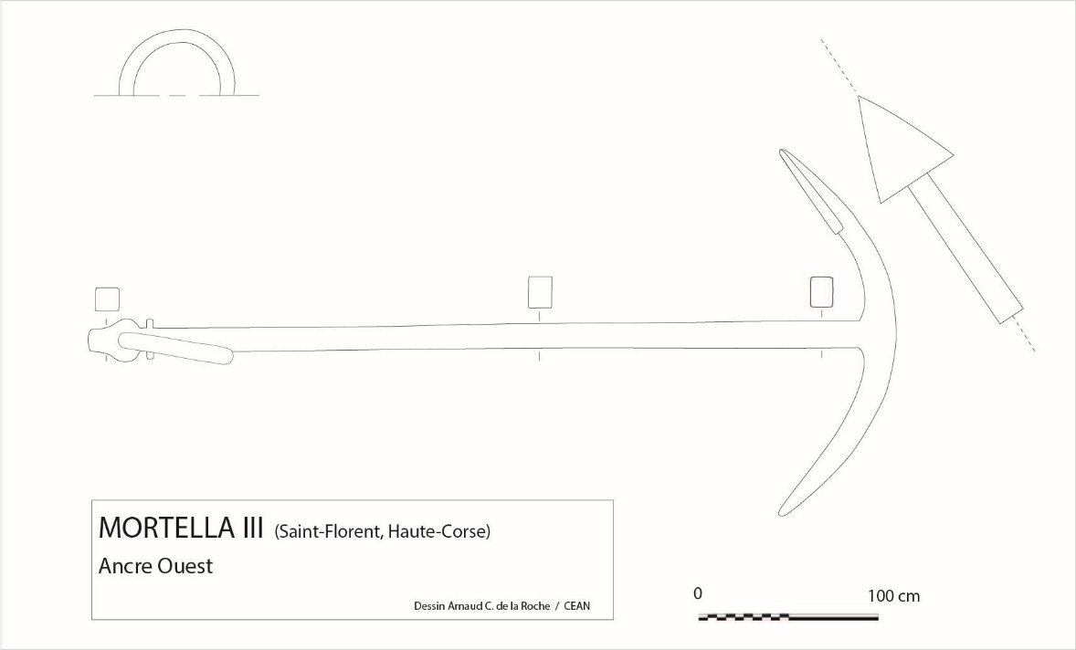

West anchor
The South anchor. It is oriented on a north/south axis, is located about 15 metres beyond the southern edge of tumulus B. It is partially buried under the sediment.

Main dimensions: Total length: 4.30 m. Arms’ span: 1.89 m. Mass: about 660 kg.

The South Anchor has the very rare characteristic of having two pairs of nuts, of which only one equivalent is known in the Ligurian Sea and another in the Adriatic Sea.

Guns

The artillery is composed by nine wrought iron stave-type cannons with a removable breech. The barrels are about 2 meters long and 35 to 40 cm in diameter. They are made of staves encircled by barrel hoops consolidated by fitting together cylindrical tubes (sleeves), themselves reinforced at their seams by rings (ribs). These cannons were named bombardas whose use in navis date from between the end of the 15th century to the 16th century.

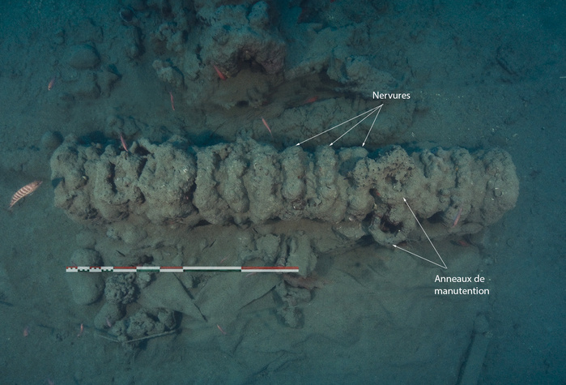
Cannon Cn3 – Photo C. Gerigk
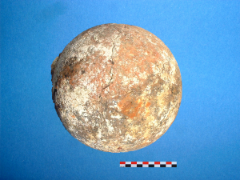

These cannons were found with stone shot. The majority of them (about twenty) are 220 mm in diameter with a mass of 16 to 17 kg and carved in serpentine, a metamorphic stone from the silicate family commonly found in the genoa’s region.
Stone shot 220 mm

Hull Remains
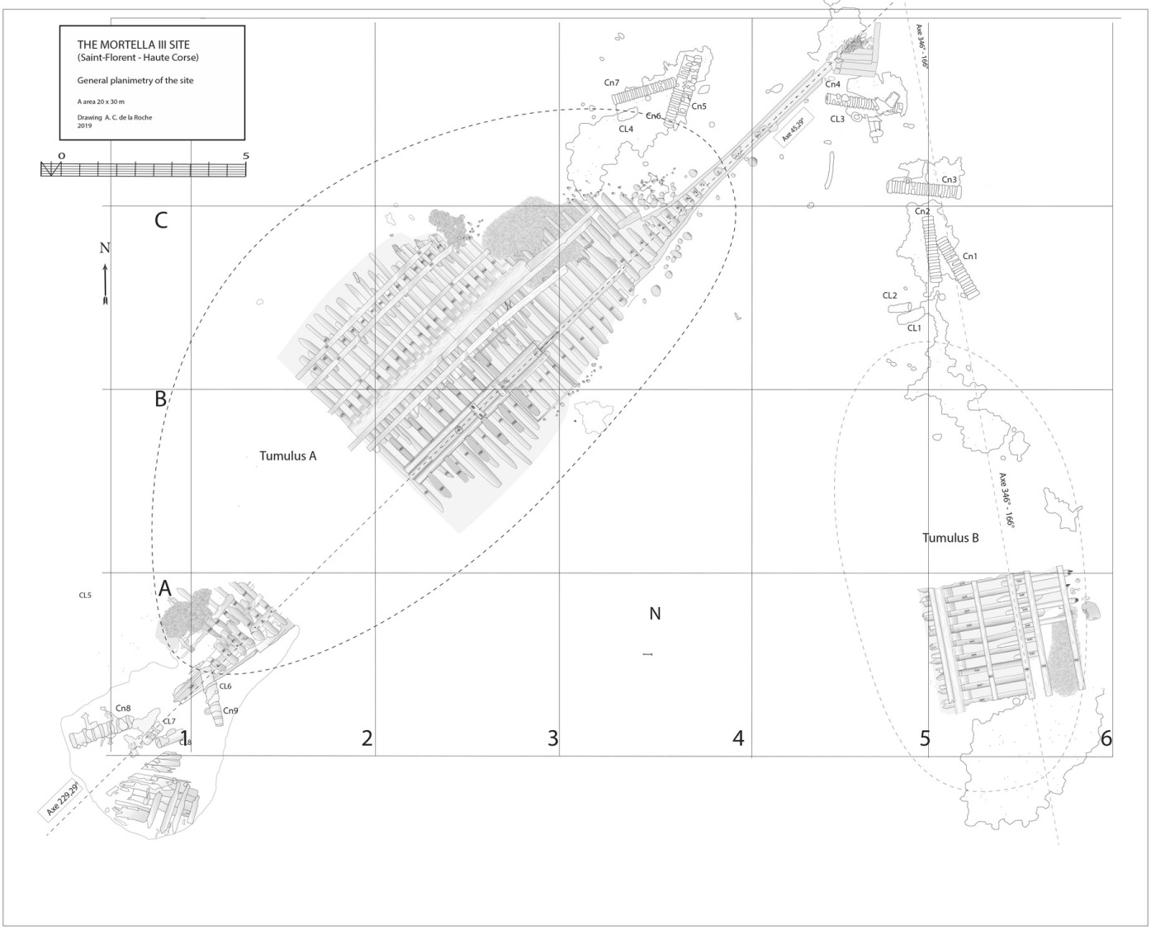
General planimetry of the site after excavation – Tumulus A (left). Tumulus B (right)

Under the tumulus A, the remains of a hull oriented along a north-east / south-west axis have been uncovered. It is a carvel “frame first” construction in oak. The keel and the keelson are preserved over its entire length but the stem post has disappeared. The heel of the keel is located in the northern part. A stern post start is visible. On the starboard side are preserved the half-frames formed by the sequence floor timbers / first-futtocks / second futtocks whose ends are heavily charred.
The transverse framework
Layout. Classically, starting from the stern to the bow, the first-futtocks are scarved to the back faces of the floor-timbers and second-futtocks up to the master-frame which has been identified as the 27th from the stern (M27). Then the sequence reverses with scarves arranged on the front faces of the timbers.
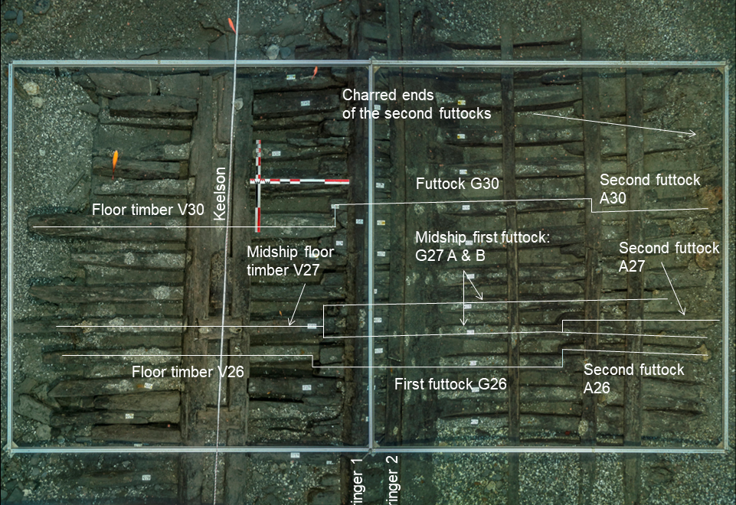
Layout of the Transverse framework – Photo C. Gerigk

The frames are broken on two points along the major length of the wreck:
- on the starboard side, the floor-timber/first-futtock scarfs collapsed down by 20 to 30°.
- on the port side only the ends of the floor-timbers have been preserved. The rest of the frame sequence, first and second futtocks, are separated from the main framework (tumulus A) and forms a second archaeological ensemble (tumulus B).
Measures. The main measures of the transverse structure recorded on the 41 frames found in tumulus A are the following:
- Floor-timbers. The master-floor has the largest length: 4.04 meters. Then, there is gradual decrease in the lengths of the following floors up to about 3.00 meters in the area of the tail-frames. The section of the timbers is roughly quadrangular. The average measures in the central part of the wreck is: Sided: 17.3 cm, Moulded: 16.7 cm. The moulded value is increasing at the aft and fore part of the wreck (averages of 20.6 cm and 19.7 cm, respectively).
- First-futtock. Length: 3.20 and 3.70 meters in the central area, in the aft and fore areas they cannot be measured accurately. Sided: 13.7 cm, Moulded: 15.3 cm (averages in central area). Moulded decreases towards the aft (12.7 cm), towards the fore part, the sampling is too small to draw a conclusion.
- Second-futtock. Only one to one and a half meter is preserved. Sided: 15.5 cm. Moulded: 15.00 cm (averages in the central of the wreck).
- Room and space (distance between the center of each floor timber) is on average 33 cm in the central area, an interval that increases towards the stern (36 cm on average) and towards the bow (34.3 cm on average).
Fastening and scarfs.
- As far as we could observe the frames located between the tail-frames, every floor-timber is fasten to the keel and the keelson with long through metallic bolts (2.5 cm in diameter).
- In the same area, hook-scarfs are attaching the floor-timbers to the first-futtocks and the first to the second-futtocks. Cross length: one meter, on average. The fastening is made with two circular iron nails of 12 mm in diameter passing through the first piece and completing their lost tip stroke in the second piece. The nailing is alternating: the first one is driven from the floor-timber to the first-futtock and the second conversely. This method is similar with that observed on the wreck of Villefranche-sur-Mer.

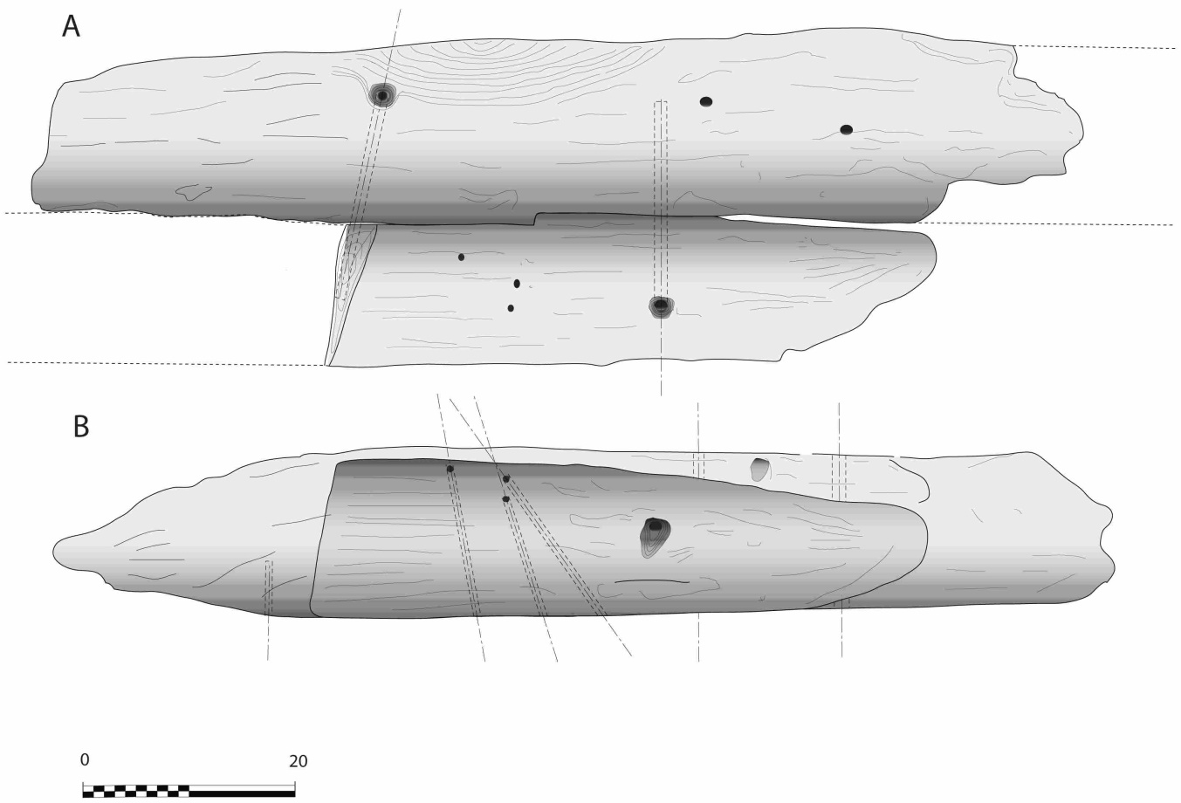
Floor-frame to first-futtock assembly with ‘hook-scarfs’

A particular feature of the nailing of the floor-timbers to the first-futtocks we could observed, is that the first nail has been driven horizontally. The second one, the closest to the extremity of the floor, had been pushed obliquely from its top to the lower part of the first-futtock side. This nailing method induces the idea of pre-assembly with a first nail, the second being placed afterward. A notable exception is the master-floor V27 nailing to its first-futtock, both of which have been horizontally driven in, confirming the particular status of the master-frame supposed to the first placed on the keel with the tail-frames.
Beyond the tail frames, toward the bow, the connection of the crutches with the first-futtocks is devoid of any scarf and fastening.
The longitudinal framework
- The keel. Its length is 25.00 meters. However, it must be taken into account that the lower part of the stern timber was initially giving to it an additional length that we estimate to be at least one meter more (overall keel evaluated to 26 meters).
A particularity of the keel is its dual morphology: it is composed of two superimposed timbers. Bottom piece, sided 20 cm, moulded 24 cm. Upper piece: sided 26 cm, moulded 24 cm.
This dual morphology enables to compensate the mechanical weakness of the connection of the keel timbers with butt-scarfs.
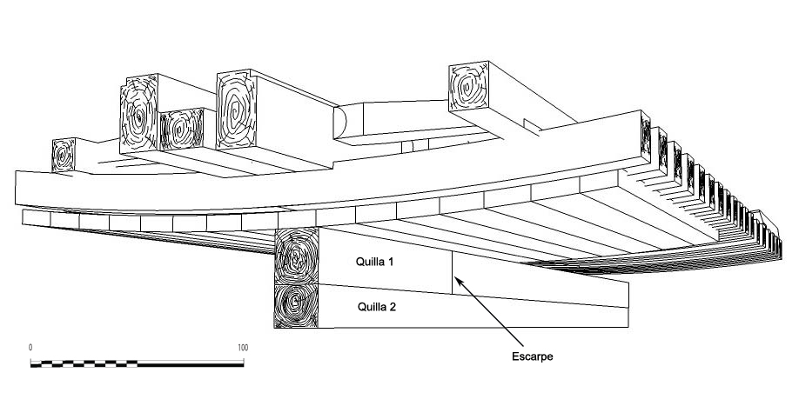
Double keel lay out

- The keelson. Dimensions: moulded 20 cm. Sided: 15 cm. It is bolted and notched to the floors.
- The clamps. The visible remains of the hull show five of them on each side notched to the frames: the first two clamps (S1 and S2) are foot wales designed to strengthen the scarf of the floors-timbers to the first-futtock. Their dimensions are closed to those of the keelson. The next one (S3) is a bilge-clamp and the next two (S4 and S5) are designed to strengthen the scarf of the first to the second futtock.
- The planking. It could only be observed partially. Samples taken are in oak. The width of the planks varies between 8 and 29 cm, the average is 17 cm. Thickness: between 8 and 9 cm in the central area of the wreck, slightly lower figures than that of the hull of the Villefranche wreck (10 to 12 cm).
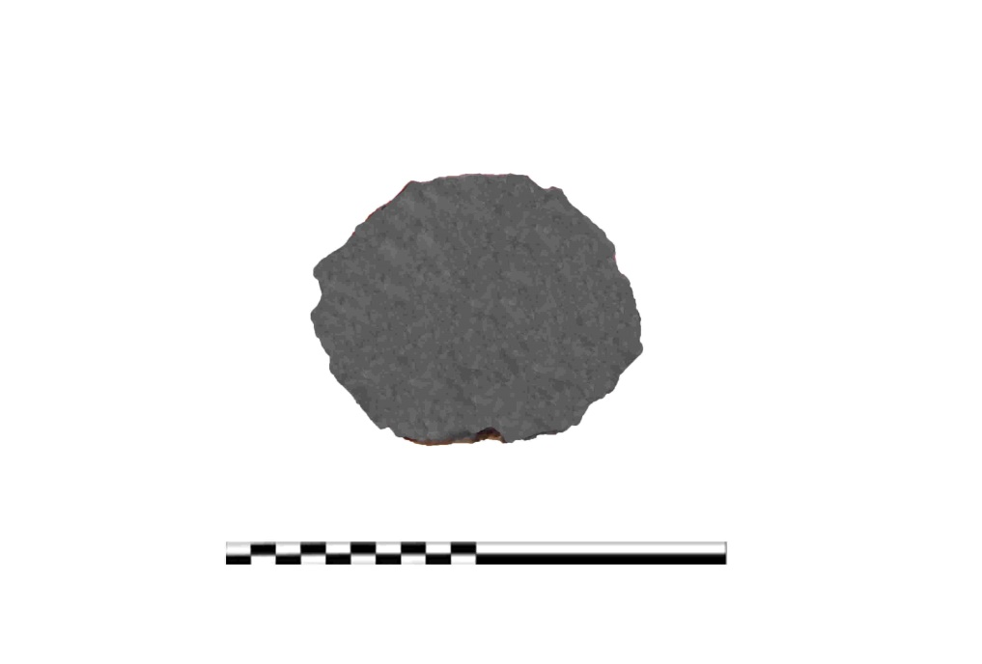
Fastening: planks are fastened to each frame with two circular iron nails of about 27 cm long / 10 mm diameter. They pass through the plank and are folded down on the inner side of the frame by about 3 to 4 cm. On the outboard face of the planks, the nails have their heads driven into the wood thanks to circular pilot holes 2 to 3 cm in diameter. This fastening system makes a notable difference with that of the wrecks of Villefranche or Red Bay where iron nails are driven into the wood with lost tips. Two texts from the 16th and 17th centuries show that this technique of folded-tipped through nails was common in the Iberian shipbuilding tradition of the Modern era. The first was written by Juan de Lasalde to the King of Spain in 1581. The second is an anonymous treaty published by Cesareo Fernandez Duro.

Circular shape of an iron nail fastening the plank to a frame

Calking: Finally, a study on caulking and sealing materials carried out by Carole Mathe (IMBE UMR 7263 - CNRS, University of Avignon) concluded that the planking was coated with pitch, pine resin and grease pitch. Unlike the wreck of Villefranche-sur-Mer, no lead coating was observed.

Main estimated measures and characteristics of the ship
Beam: 10.50 m
Keel Length: 26 m
Length Overall: 37 m
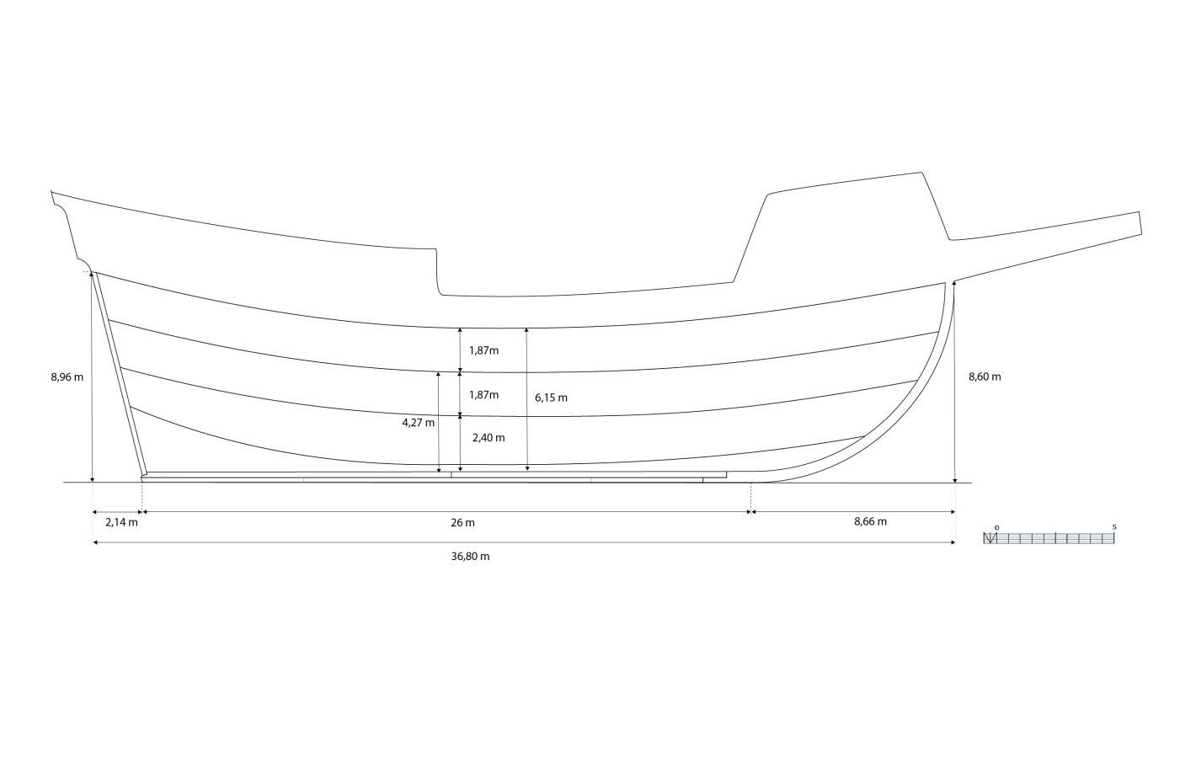
Depth of hold (to the 2d deck): 6.15 m
Number of Masts: 3
Estimated burden: 550 to 570 tons (11.600 to 11.900 cantars).

Main longitudinal/vertical measures
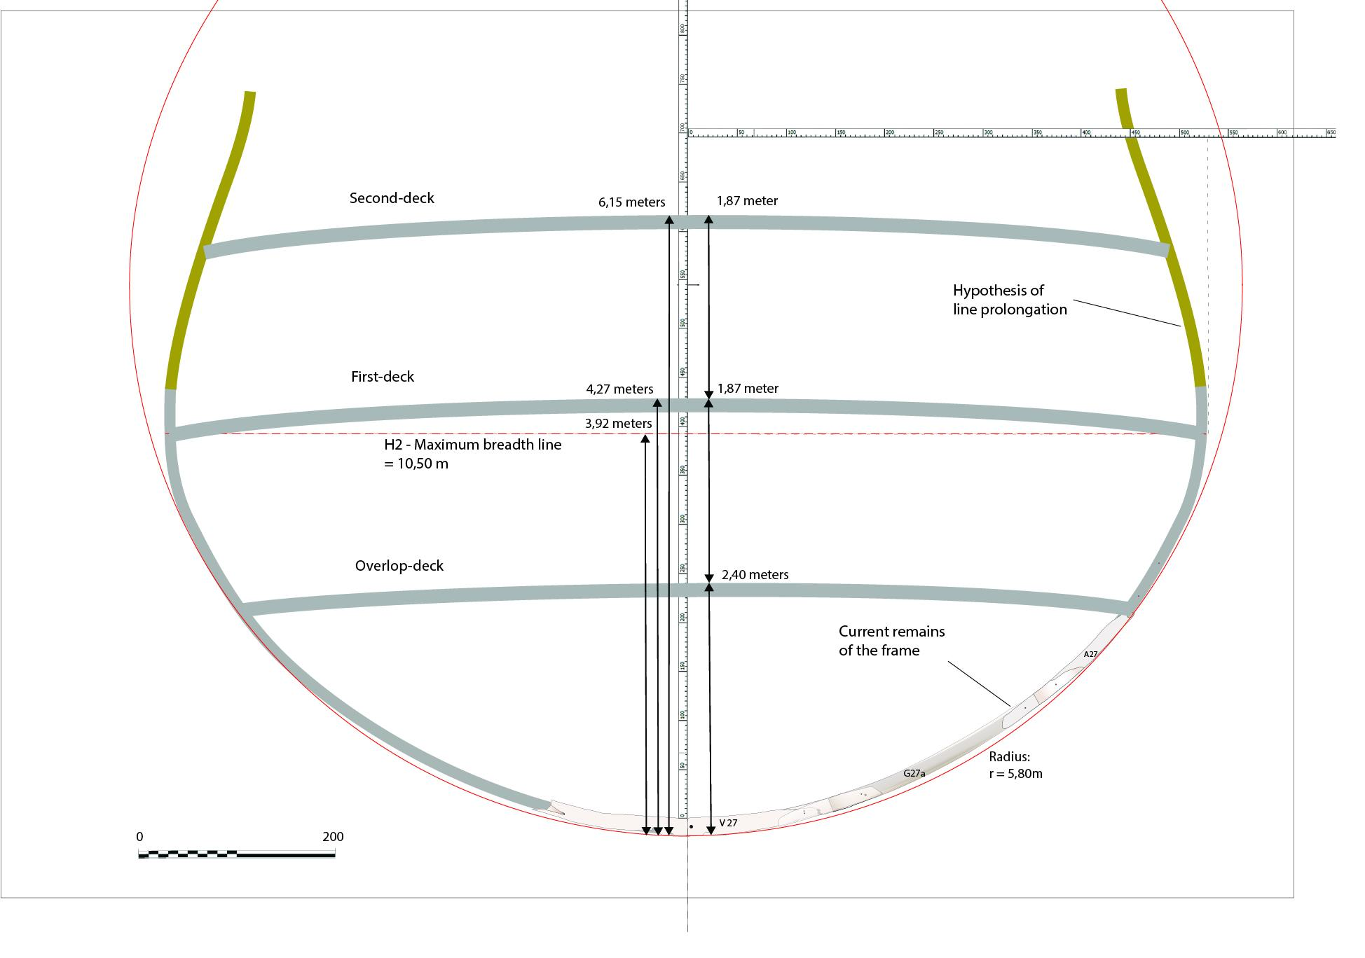

Transverse shape hypothesis at maximum breadth (remains of the master-frame)

Deliverables
Excavation Reports and articles visible on Academia:
- 2020 - The Mortella III Wreck: a Spotlight on Mediterranean Shipbuilding of the 16th Century:
https://www.academia.edu/42491807/The_Mortella_III_Wreck_a_Spotlight_on_Mediterranean_Shipbuilding_of_the_16th_Century

El pecio de la Mortella III (Córcega, Francia): un aporte al conocimiento de la arquitectura naval del siglo XVI en el Mediterráneo, 2014:
https://www.academia.edu/10243987/El_pecio_de_la_Mortella_III_C%C3%B3rcega_Francia_un_aporte_al_conocimiento_de_la_arquitectura_naval_del_siglo_XVI_en_el_Mediterr%C3%A1neo
- Summary of the excavations reports of the year 2010, 2012 and 2013:
https://csic.academia.edu/ArnaudCazenavedelaRoche

Publications
Cazenave de la Roche, A., La construction navale au XVIème siècle en Méditerranée: l’apport de l’épave de la Mortella III (Saint-Florent, Haute-Corse). Editions Mergoil, (under publication).
Cazenave de la Roche, A., The Mortella III wreck: a spotlight on Mediterranean Shipbuilding of the 16th century. British Archaeology Report – BAR Publishing, Oxford, 2020.
Cazenave de la Roche, A., « Bilan scientifique de la campagne de fouilles de l’épave de la Mortella III de l’année 2014 » in Bilan scientifique du DRASSM, Marseille, 2020
Cazenave de la Roche, A., « La construction navale au XVIème siècle en Méditerranée : l’apport de l’épave de la Mortella III (Saint-Florent, Haute-Corse) », position de thèse, in Histoire Maritime, Presses Sorbonne Université, 2018, p.189-200.
Cazenave de la Roche, A., « La construction navale au XVIème siècle en Méditerranée : l’apport de l’épave de la Mortella III (Saint-Florent, Haute-Corse) ». Doctoral Thesis, February 2018.
Cazenave de la Roche, A., « Les épaves de la Mortella…» in Exhibition catalogue « Secrets d’épaves, 50 ans d’archéologie sous-marine en Corse. Edition of the Bastia Museum, July 2017, p.54-59.
Cazenave de la Roche, A., « Bilan scientifique de la campagne de fouilles de l’épave de la Mortella III de l’année 2015 » in Bilan scientifique du DRASSM, Marseille, 2017
Cazenave de la Roche, A., « L’épave de la Mortella III (Saint-Florent, Haute-Corse) : le témoignage d’un grand vaisseau méditerranéen du XVIème siècle naufragé en Corse. » In Naufrages, épaves et archéologie sous-marine. Médiathèque Culturelle de la Corse et des Corses (dir. Michel Vergé-Franceschi). Actes des XVIIèmes Journées Universitaires d'Histoire Maritime de Bonifacio (Corse du Sud), Bonifacio May 2015, p.95-120.
Cazenave de la Roche, A., “El pecio de la Mortella III (Córcega, Francia): un aporte al conocimiento de la arquitectura naval del siglo XVI en el Mediterráneo.” Proceedings of l’Internationaler Kongreß für Unterwasserarchäologie, IKUWA V (oct.2014), 863-870, 2016
Cazenave de la Roche, A., “Bilan scientifique de la campagne de fouilles de l’épave de la Mortella III de l’année 2010» in Bilan scientifique du DRASSM. 2014.
Cazenave de la Roche, A., “The Renaissance shipwrecks of the Saint-Florent bay (Mortella II and III) two sites of a high archaeological potential in Corsica (France)”. International Journal of Nautical Archaeology, IJNA, 40.1, 69-86, 2011.
Cazenave de la Roche, A., « Observations préliminaires sur des sites archéologiques de la période de la Renaissance dans la baie de Saint-Florent (Haute-Corse). » Les Cahiers d’Archéologie Subaquatique –CAS-. Novembre/décembre 2009, nºXVII, p.5 – 53.
Cazenave de la Roche, A., « La Mortella II et III : des épaves de vaisseaux de la Renaissance dans la baie de Saint-Florent. » Stantari, Novembre 2008.
Gendron, F. Étude comparée du lest des épaves Mortella II et III ; baie de Saint-Florent, région du Nebbio (Haute-Corse) ; Cahiers d’Archéologie Subaquatique, XVII, 2009 ; p. 55-61.
Langenegger, Fabien, « Étude dendrochronologique de l’épave de la Mortella III (Baie de Saint-Florent, Haute-Corse) », in Cazenave de la Roche, A., The Mortella III wreck: a spotlight on Mediterranean Shipbuilding of the 16th century. British Archaeology Report – BAR Publishing, Oxford, 2020, p. 177-190.
Langenegger, Fabien, « Étude de la compression transversal des bois de l’épave de la Mortella III », in Cazenave de la Roche, A., The Mortella III wreck: a spotlight on Mediterranean Shipbuilding of the 16th century. British Archaeology Report – BAR Publishing, Oxford, 2020, p. 177-190.
Mathe, Carole, “Chemical analysis of caulking and sealing materials”, in Cazenave de la Roche, A., The Mortella III wreck: a spotlight on Mediterranean Shipbuilding of the 16th century. British Archaeology Report – BAR Publishing, Oxford, 2020, p. 197-202.

Giustiniani, Agostino, 1537, Castigatissimi annali con la loro copiosa tavola della Eccelsa et Illustrissima Repubblica di Genova, Genoa. Ed. Cambridge (Mass.),1990
Giovio, P. 1552, Histoires sur les choses faictes et avenues de son temps en toutes les parties du monde, vol.II, ed. Guillaume Roville, Lyon.
Guérout, M, Gassend, J.M, et Rieth, E., 1989, « Le navire génois de Villefranche, un naufrage de 1516 ( ?) », Archaeonautica n°9, Edition du CNRS, p. 43.
Lasalde, Juan de, 1581, “Juan de Lasalde al rey ofreciéndose para la fabricación de 8 galeones, mayo 1581”, MNM, Colección Fernández Navarrete, T.XXII, doc.76, reales cédulas expedidas por el rey a Cristóbal de Barros y siete pareceres…, f°299-301
Anonyme, XVIIIème s., “Tratado de galafatería” texte du XVIIème s., dans Fernández Duro, Cesáreo, 1888, Disquiciones Náuticas, Ed. del Ministerio de defensa, Instituto de Historia y Cultura Naval, Madrid, 1996, vol. VI, p.243.

